Goalie Drills!
Being a soccer goalie can be hard work. Everyone expects you to make that all important save. However, if you don't you can be seen as the person who lost the team their game.
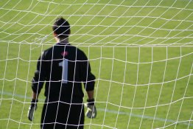
The goalie is a player different to the rest of the team in so fact that they can use their hands during a game inside their own penalty area.
Goalkeeper Drills
Beginner Goalie Drills
Intermediate Goalie Drills
Advanced Goalie Drills
It can be an incredibly fun position for any aged player if you possess a few qualities. Take a look at my recommendations below and see what you think.
Three important (but not always essential) qualities to play in goal are:
1. Reactions - being able to think quickly enough and react to a shot
2. Anticipation - to anticipate where a shot might be going or intercepting a through ball from the opposing team
3. Shot-stopper - being brave in the challenge, strong enough to clear a ball and confident to claim the ball over team-mates.
Three important qualities that can be coached to goal-keepers in order to make them better. It is of course advantageous to have a soccer goalie who is big, strong and tall.
A tall goal-keeper in theory can save more shots especially high shots as well as claiming the ball in their hands over players' heads.
Being big and strong allows the goal-keeper to look and feel intimidating toward the opposing team.
Many goalies however are not tall, big or particularly strong and make excellent keepers because they possess the three qualities listed above.
Fabien Barthez (ex - Manchester United and French national team) goal-keeper was not the tallest of people but he was very agile and was regarded as a world class goalie.
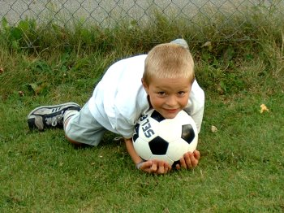
The young child in the picture is showing a good technique for stopping a shot. He has his body behind the ball and both hands comfortably on the ball. Known as smothering the ball.
The young goalies or those new to goal-keeping must start with simple ball-handling skills to help them get used to holding a soccer ball.
For more advanced/older goalies there are drills that will help them improve their reactions, shot-stopping techniques, anticipation and many more!

