U7 Through the Gates

Football coaching should be about showing children the basics and then allowing them to learn and make their own mistakes.
Preparation
Take a look at the diagram below. The players will have their own ball each and be spread out in the area.
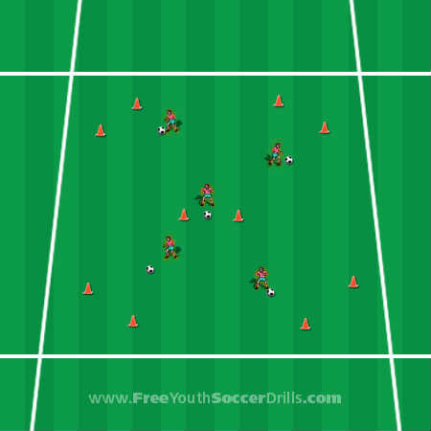

Explanation
This drill is very good at getting the young players to dribble in different directions at pace and with good control. On the coaches command the players will dribble their soccer ball around the area and dribble through as many gates as possible.
Once the kids have been through the gates the game needs to advance to adding in tricks and turns. Different variations are where after a player has been through a gate they have to do a trick or skill. Take a look at what I recommend below:
1. Drag back / pull back turn
2. Inside hook turn
3. Outside hook turn
4. Scissors (skill)
*** To see football coaching skills and turns... please click on the 'skills & tricks' page on the left hand side ***
The great thing about this coaching drill is that there are loads of different variations to the game. At the end of each game where the players have gone through the gates ask the kids how many they went through and get some players to demonstrate to everyone their turn/skill with plenty of positive feedback then a small helpful comment / progression.
For example, "Jimmy, well done on doing such a great turn. Let’s show everyone again... that was really good! Next time, how about looking over your shoulder before you turn to make sure you don't bump into anybody"
There are loads of different skills and turns and additional mini games you can add into the 'through the gates' game. The older and more competent players should have more complex drills but will still enjoy this football coaching drill.
Progression
Try adding more gates with a time restriction so the players have to dribble faster to get through all the gates. This will ultimately put pressure on them and it will be harder to begin with to control their ball. In contrast you could try only having 3 gates in a smaller area so the kids are more likely to bump into each other and therefore good control on the ball, looking up and changing direction are very important to this football coaching drill.
Coaching Points
-> Make sure the kids use little touches and demonstrate what happens if you kick the ball too far in a game.
-> Make sure the kids use the inside and outside of their feet while dribbling - not their toes.
-> Demonstrate every turn that you use and show the players how this could work in a game situation.
-> Make sure the kids change direction frequently and keep their heads up to see where they are going and ensure they do not bump into anyone.

