U7 World Cup Passing!

This backyard soccer game is great for coaching kids how to pass the soccer ball correctly and accurately. I have used this drill for adult soccer players as a quick, relaxed warm up game and it always goes down well.
Preparation
Take a look at the diagram below for World Cup Passing - backyard soccer style. You will see that there are cones in the grid with players either side. A ball placed on the cone with another ball at a players feet.
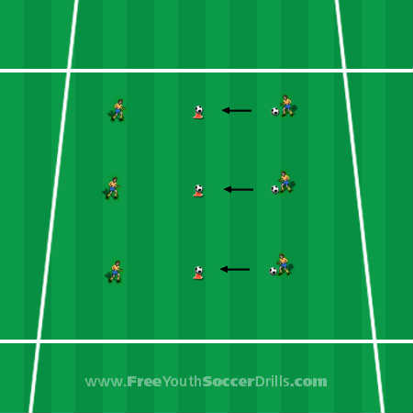

Explanation
This soccer game is great fun for this age group and also ideal at improving players passing technique and accuracy.
The basic idea to this backyard soccer drill will be for the player to pass the ball at their feet toward the soccer ball balanced on top of the cone. If the player knocks the ball off they will receive two points, if they touch the ball without it falling off they receive one point. If the ball falls off then it must be replaced. Time the game and give the kids a couple of minutes to improve their accuracy.
There are plenty of progression ideas for this drill. I always like to start without the soccer ball on the center cone and allow the players to pass the ball to one another. Once every-one is comfortable with basic passing then the ball can be placed upon the center cone and the game can begin by shouting "GO!” World cup passing becomes more exciting with players counting their score and telling the coach at the end of the game who has the most points. Points could be recorded by the coach or the winner of one game could play the winner of another game until there is a champion.
Progression
A great progression to this backyard soccer game which I use for the older kids as well (as a fun warm up game) is the use of player’s bodies. Get the players into groups of three and get one player to stand where the cone was with their legs wide open. The game now is to pass the ball between the players' legs for two points or you get one point for hitting the legs.
After two minutes, swap the player in the middle and allow the other two to battle it out.
Another progression to this game (for older players perhaps) can be the short pass, long pass drill. Still in the same positions and in groups of three, the player on the outside will pass to the player in the middle who will receive the ball and turn to face the other player who will then pass the ball to the other outside player they are facing. This is brilliant at getting the kids to use turns and flicks and demonstrated in the skills section of my website.
Coaching Points
-> Demonstrate clearly the ABC of passing and get one of the players to show everyone else.
-> Make sure the kids use little touches and demonstrate what happens if you kick the ball too far in a game.
-> Make sure the kids use the inside and outside of their feet whilst dribbling - not their toes.
-> Demonstrate every turn that you use and show the players how this could work in a game situation.
-> Make sure the kids change direction frequently and keep their heads up to see where they are going and ensure they do not bump into anyone.

