SEVENTH SUNDAY OF EASTER – 5.21.23

A BIG THANK YOU - to everyone who made our Bazaar yesterday such a great success. It was a team effort in every way! Thanks for this great outreach into the community.
New Bible Study – Open to all! Come and join us at Connie Pinkowski’s home - 4 E 26th St. Barnegat Light, , 908-462-4499. Just show up, there’ll be goodies for everyone!
The LBI Schools PTA is holding a clothing drive on Saturday, 03 JUN from 9am-1pm at Ethel A Jacobsen elementary, on Barnegat Avenue in Surf City to benefit the Ethel A Jacobsen and Ship Bottom Schools. We are collecting used clothing, accessories, household linens, stuffed animals, bikes and scooters. If you’d like to donate but can’t make it to the school on 03 JUN, please bring your donation to Zion Church on Sundays (10am mass), where the Barrett’s will gladly collect them for you or contact Wes (862-505-9183) for local pick up.
Walking Wednesdays! We’re looking to gather walkers of every age and endurance to come and walk every Wednesday Morning as the new Summer Season falls upon us. We will gather at 8am at Zion and divide ourselves into different groups to have a walk together. Why? To get a good exercise program in our schedule and to meet some of the nicest people in the world! Zion’s friends and members. For more info call or email Sharon Joyce (267-566-5640) or Sandbjoyce79@gmail.com . We begin on Sat. 7th at 8 am! Cu all there, bring a neighbor or a friend!

Blessed be the holy Trinity, ☩ one God,
who forgives all our sin, whose mercy endures forever. Amen.

God of all mercy and consolation, come to the help of your people, turning us from our sin to live for you alone. Give us the power of your Holy Spirit that we may confess our sin, receive your forgiveness, and grow into the fullness of Jesus Christ, our Savior and Lord. Amen.

Let us confess our sin in the presence of God and of one another. (Silence)

Most merciful God, we confess that we are captive to sin and cannot free ourselves. We have sinned against you in thought, word, and deed, by what we have done and by what we have left undone. We have not loved you with our whole heart; we have not loved our neighbors as ourselves. For the sake of your Son, Jesus Christ, have mercy on us. Forgive us, renew us, and lead us, so that we may delight in your will and walk in your ways, to the glory of your holy name. Amen.

May Almighty God have mercy on us, forgive us our sins and bring us to life everlasting. Amen!

HYMN: #393 – A HYMN OF GLORY LET US SING

Prayer of the Day
O God of glory, your Son Jesus Christ suffered for us and ascended to your right hand. Unite us with Christ and each other in suffering and in joy, that all the world may be drawn into your bountiful presence, through Jesus Christ, our Savior and Lord, who lives and reigns with you and the Holy Spirit, one God, now and forever. Amen.

First Reading: Acts 1:6-14
⁶When [the apostles] had come together, they asked [Jesus], “Lord, is this the time when you will restore the kingdom to Israel?” ⁷He replied, “It is not for you to know the times or periods that the Father has set by his own authority. ⁸But you will receive power when the Holy Spirit has come upon you; and you will be my witnesses in Jerusalem, in all Judea and Samaria, and to the ends of the earth.” ⁹When he had said this, as they were watching, he was lifted up, and a cloud took him out of their sight. ¹⁰While he was going and they were gazing up toward heaven, suddenly two men in white robes stood by them. ¹¹They said, “Men of Galilee, why do you stand looking up toward heaven? This Jesus, who has been taken up from you into heaven, will come in the same way as you saw him go into heaven.”
¹²Then they returned to Jerusalem from the mount called Olivet, which is near Jerusalem, a sabbath day’s journey away. ¹³When they had entered the city, they went to the room upstairs where they were staying, Peter, and John, and James, and Andrew, Philip and Thomas, Bartholomew and Matthew, James son of Alphaeus, and Simon the Zealot, and Judas son of James. ¹⁴All these were constantly devoting themselves to prayer, together with certain women, including Mary the mother of Jesus, as well as his brothers. The Word of the Lord…Thanks be to God!

Psalm 68: 32-35
³²Sing to God, O kingdoms of the earth;
sing praises to the Lord.
³³You ride in the heavens, O God, in the ancient heavens;
you send forth your voice, your mighty voice.
³⁴Ascribe power to God,
whose majesty is over Israel; whose strength is in the skies.
³⁵How wonderful you are in your holy places, O God of Israel,
giving strength and power to your people! Blessed be God!

A Reading from the Holy Gospel according to John 17:1-11 – Glory to You, O Lord!
¹After Jesus had spoken these words to his disciples, he looked up to heaven and said, “Father, the hour has come; glorify your Son so that the Son may glorify you, ²since you have given him authority over all people, to give eternal life to all whom you have given him. ³And this is eternal life, that they may know you, the only true God, and Jesus Christ whom you have sent. ⁴I glorified you on earth by finishing the work that you gave me to do. ⁵So now, Father, glorify me in your own presence with the glory that I had in your presence before the world existed.
⁶“I have made your name known to those whom you gave me from the world. They were yours, and you gave them to me, and they have kept your word. ⁷Now they know that everything you have given me is from you; ⁸for the words that you gave to me I have given to them, and they have received them and know in truth that I came from you; and they have believed that you sent me. ⁹I am asking on their behalf; I am not asking on behalf of the world, but on behalf of those whom you gave me, because they are yours. ¹⁰All mine are yours, and yours are mine; and I have been glorified in them. ¹¹And now I am no longer in the world, but they are in the world, and I am coming to you. Holy Father, protect them in your name that you have given me, so that they may be one, as we are one.”

REFLECTIONS

HYMN: Yet Not I But Through Christ In Me!
- What gift of grace is Jesus my Redeemer, There is no more for Heaven now to give. He is my joy, my righteousness and freedom, My steadfast love, my deep and boundless peace. To this I hold, my hope is only Jesus, For my life is wholly bound to His. Oh, how strange and divine, I can sing, "all is mine", Yet not I but through Christ in me.

- The night is dark but I am not forsaken, For by my side the Savior He will stay. I labor on in weakness and rejoicing, For in my need His power is displayed. To this I hold, my Shepherd will defend me Through the deepest valley He will lead. Oh, the night has been won and I shall overcome, Yet not I but through Christ in me.

- No fate I dread, I know I am forgiven, The future sure, the price it has been paid. For Jesus bled and suffered for my pardon.
And He was raised to overthrow the grave. To this I hold, my sin has been defeated, Jesus now and ever is my plea. Oh, the chains are released, I can sing "I am free". Yet not I but through Christ in me.

- With every breath I long to follow Jesus, For He has said that He will bring me home. And day by day, I know He will renew me
Until I stand with joy before the throne. To this I hold, my hope is only Jesus, All the glory evermore to Him When the race is complete, still my lips shall repeat. Yet not I but through Christ in me.
Prayers of Intercession

United in the hope and joy of the resurrection, let us pray for the church, the world, and all in need. (A brief silence.)
As your Spirit hovered over the waters of creation, so your Spirit hovers over all that you have made. Bless the water that sustains the planet and grant wisdom to use it wisely.
You empower your people with the fire of your Spirit. Challenge activists and organizers, teachers and politicians, and all in leadership to speak a message of peace and justice.
You care for all your children. Show your steadfast love to those suffering isolation, especially exiles, refugees, or prisoners. Break the chains of all held fast by systemic oppression of any kind.
Lord Jesus, Comfort all who are afraid or suffering from illness (especially we pray for these sisters and brothers of ours).
You raise your saints to new life in Christ. We give you thanks for all your saints who have given us glimpses of your redeeming love.
Rejoicing in the victory of Christ’s resurrection, we lift our prayers and praise to you, almighty and eternal God; through Christ, our risen Lord. Amen.

Offering Prayer
Generous God, in this meal you offer your very self. We give thanks for these gifts of the earth. In the breaking of this bread reveal to us the Risen One. In the pouring of this wine pour us out in service to the world; through Christ our Lord. Amen.

THE GREAT THANKSGIVING
LORD’S PRAYER
Our Father, who art in heaven, hallowed be thy name,thy kingdom come, thy will be done,
on earth as it is in heaven.
Give us this day our daily bread;
and forgive us our trespasses,
as we forgive those who trespass against us;
and lead us not into temptation, but deliver us from evil.
For thine is the kingdom, and the power, and the glory,
forever and ever. Amen.

Invitation to Communion - Come forward and experience the love of Jesus Christ, broken and poured out for you.
[Ushers will escort you to the Communion Rail to receive.
After receiving the wafer, (GLUTEN FREE WAFERS AVAILABLE)
you will be able to take a small cup of wine (red) or grape juice (white) from a tray. Deposit the empty cup in the basket. Then return to you seat.]

OUR TIME OF COMMUNION WITH THE LORD!

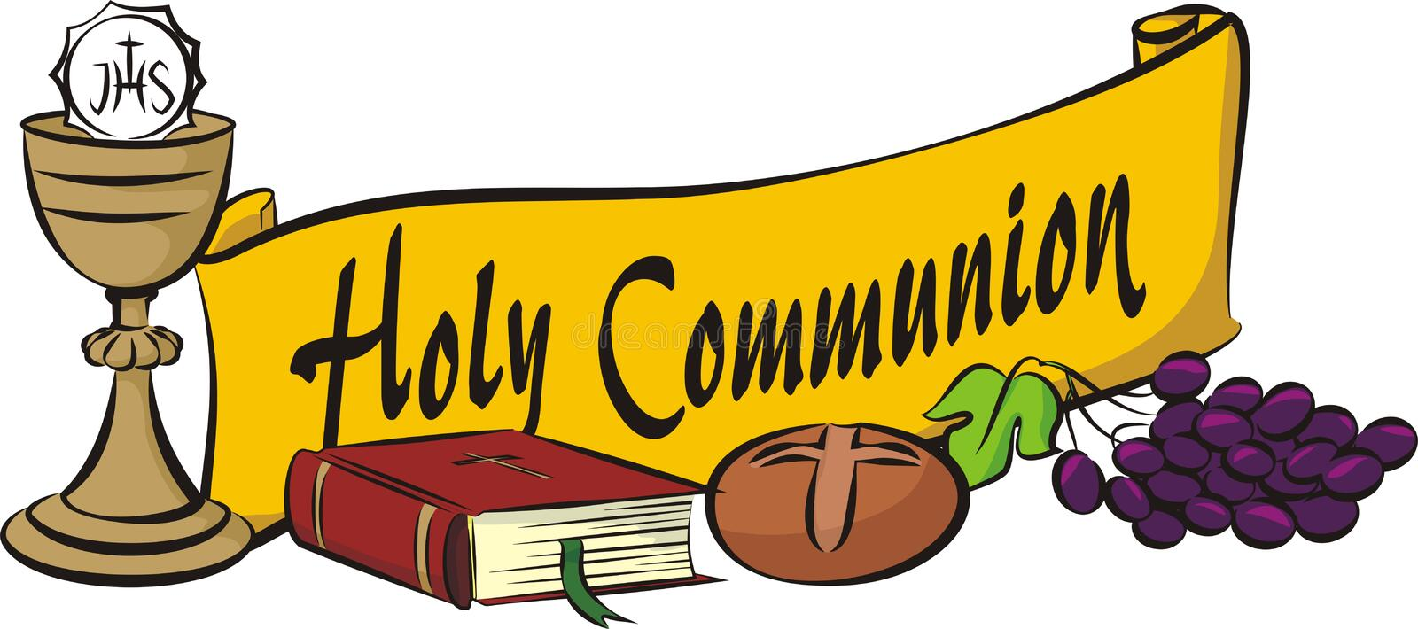

HYMN – Alleluia! Sing to Jesus

1 Alleluia! Sing to Jesus; his the scepter, his the throne;
Alleluia! his the triumph, his the victory alone.
Hark! The songs of peaceful Zion thunder like a mighty flood:
"Jesus out of ev'ry nation has redeemed us by his blood."

2 Alleluia! Not as orphans are we left in sorrow now;
Alleluia! he is near us; faith believes, nor questions how.
Though the cloud from sight received him when the forty days were o'er,
shall our hearts forget his promise: "I am with you evermore"?

3 Alleluia! Bread of heaven, here on earth our food, our stay;
Alleluia! here the sinful flee to you from day to day.
Intercessor, friend of sinners, earth's redeemer, hear our plea
where the songs of all the sinless sweep across the crystal sea.

4 Alleluia! King eternal, Lord omnipotent we own;
Alleluia! born of Mary, earth your footstool, heav'n your throne.
As within the veil you entered, robed in flesh, our great high priest,
here on earth both priest and victim in the eucharistic feast.

5 Alleluia! Sing to Jesus; his the scepter, his the throne;
Alleluia! his the triumph, his the victory alone.
Hark! The songs of peaceful Zion thunder like a mighty flood:
"Jesus out of ev'ry nation has redeemed us by his blood."
Text: William C. Dix, 1837-1898, alt.

Prayer after Communion - Gracious God, in you we live and move and have our being. With your word and this meal of grace, you have nourished our life together. Strengthen us to show your love and serve the world in Jesus’ name. Amen.

Blessing – Now may the God of all, who raised ☩ Jesus from the dead, bless you by the power of the Holy Spirit to live in the new creation. Amen.

HYMN: #400 – GOD OF TEMPEST, GOD OF WHIRLWIND

Dismissal - Go in peace. Love and Serve the Lord!

Thanks be to God.

18th Street & Central Ave.

Barnegat Light, New Jersey
609-494-8676
Pastor Bill McGowan, Pastor - 484-798-3929
zionchurchlbi@gmail.com – zionlbi.com

“God calls us to share our faith in Christ
with the community in all seasons!

