MAUNDY THURSDAY
Rite II
April 9, 2009
7:00 P.M.

Opening Hymn SongBook 113 “This is my Father's world”
BCP Page 355 Opening Acclamation
Back page “Peace before us”
Insert Collect (BCP p. 274), Lessons
Insert PSALM 116:1-2,12-17 (p. 759)
Gradual Hymn 577, verses 1-2 “God is love, and where true love”
Gospel JOHN 13:1-17, 31b-35
Gradual Hymn 577, verse 3
Homily: The Rev. Scott Fisher

THE FOOTWASHING
Hymns 602 “Jesu, Jesu, fill us with your love”
SongBook 97, 107, 14b, 17, 18, 32, 43b, 45, 59, 93a
The Peace

Offertory Hymn 304 “I come with joy to meet my Lord”
(Offering is given to our relatives at Congregation OrHatzafon)

Page 372 The Great Thanksgiving -Euch Prayer D
Page 373 Sanctus (Hymnal S-129)
Page 364 The Lord's Prayer
Page 364 Fraction(Hymnal S-155)
Sentence of Invitation
Communion Hymns: SongBook 9a, 27a, 40, 105a, 108b

STRIPPING OF THE ALTAR (Altar Guild)
(ALL Altar Guild members are invited to assist)
All Depart in Silence

FLOWER & PALMS OFFERING
The palms and flowers are given to the Glory of God, and in thanksgiving
for our co-Sacristans, CATHY GIACOMAZZI & MARY JOHNSTON, and
ALL of our ALTAR GUILD MEMBERS.
THOSE ASSISTING IN THE LITURGY:
Crucifer/Acolyte:
First Lesson: Julia Cockerille
Psalm Reader: Kathy Mackey
Second Lesson: Bernice Aragon
Prayer Leader:
Chalice Bearer: Shirley Lee
Communion Bread: Beverly Joseph
Organist: Mary Ellen Koeller
Altar Guild: All Members
Ushers:

OUR PRAYERS OF INTERCESSIONS
We pray tonight for those preparing to be Baptized this Easter, their Godparents, and all of us who are renewing our Baptismal Vows:

The Candidates for Baptism:
KADIN MATTHEW DINWOODIE
JESSE ALLEN HAMNER
MEGAN LEIGH LUNDEMO
CHRISTOPHER RAYE SKOGSTAD
DAPHNE NICHOLE SWEET
HOLLY TRACIA TRITT
ECHO YUNA-MARIE ZIPPORAH-HORAN

+ + +

Good Friday ~ Noon Tanana Valley Christian Conference
Community Service @ 1st Presbyterian
7:00 PM Good Friday Liturgy

Holy Saturday ~ 10:00 AM Holy Saturday liturgy
10:30 AM Baptism Rehearsal,
Altar Guild Church decorating
8:00 PM Easter Fire, Baptisms, Eucharist
Easter Sunday ~ 8:00, 9:15, & 11:15 AM Holy Eucharist
2 PM Children’s Easter Egg Hunt (parish hall)

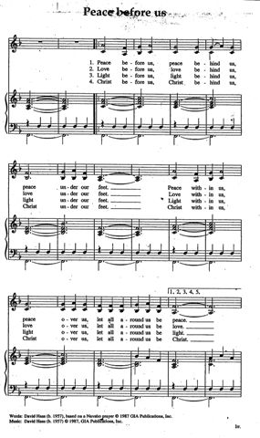

MAUNDY THURSDAY
April 9, 2009

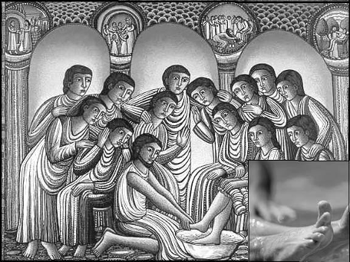

ST. MATTHEW'S EPISCOPAL CHURCH
Fairbanks, Alaska
The Rev. Scott Fisher, Rector

www.stmatthewschurch.org
www.episcopalak.org
www.alaskabishopsearch.org

