Fourth Sunday after the Epiphany

Sunday January 31, 2021
Year B & Daily Office Year One
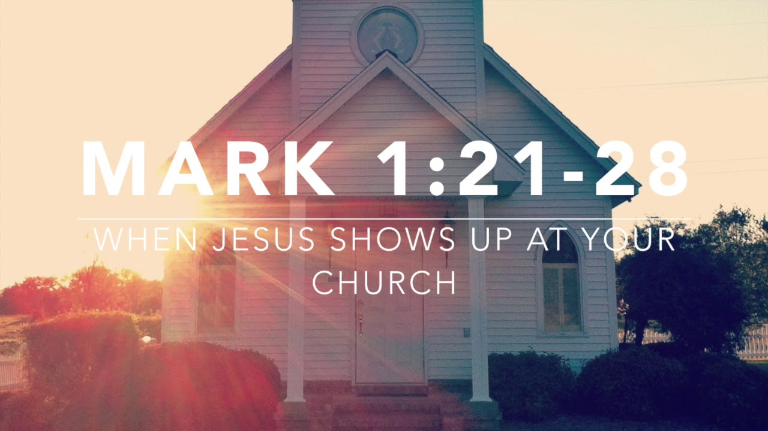

The Episcopal Churches In
Fairbanks & North Pole

The Rt. Rev. Mark Lattime, Bishop
The Rev. John Holz, St. Jude’s, North Pole
The Rev. Betty M. Glover, St. Matthew’s, Fairbanks

The Word of God

Entrance Rite

Entrance Hymn #339, v1 – “Deck thyself, my soul, with gladness”

Opening Acclamation (BCP p. 355)
 | Blessed be God: Father, Son, and Holy Spirit.
People | And blessed be his kingdom, now and for ever. Amen.

Collect for Purity
Almighty God, to you all hearts are open, all desires known, and from you no secrets are hid: Cleanse the thoughts of our hearts by the inspiration of your Holy Spirit, that we may perfectly love you, and worthily magnify your holy Name; through Christ our Lord. Amen.

Gloria
Glory to God in the highest,
and peace to his people on earth.
Lord God, heavenly King,
almighty God and Father,
we worship you, we give you thanks,
we praise you for your glory.
Lord Jesus Christ, only Son of the Father,
Lord God, Lamb of God,
you take away the sin of the world:
have mercy on us;
you are seated at the right hand of the Father:
receive our prayer.
For you alone are the Holy One,
you alone are the Lord,
you alone are the Most High,
Jesus Christ,
with the Holy Spirit,
in the glory of God the Father. Amen.

The Collect of the Day
Celebrant | The Lord be with you.
People | And also with you.
Celebrant | Let us pray.

Almighty and everlasting God, you govern all things both in heaven and on earth: Mercifully hear the supplications of your people, and in our time grant us your peace; through Jesus Christ our Lord, who lives and reigns with you and the Holy Spirit, one God, for ever and ever. Amen.

The Lessons

Psalm: Psalm 111
¹Hallelujah!
I will give thanks to the Lord with my whole heart, *
in the assembly of the upright, in the congregation.
²Great are the deeds of the Lord! *
they are studied by all who delight in them.
³His work is full of majesty and splendor, *
and his righteousness endures forever.
⁴He makes his marvelous works to be remembered; *
the Lord is gracious and full of compassion.
⁵He gives food to those who fear him; *
he is ever mindful of his covenant.
⁶He has shown his people the power of his works *
in giving them the lands of the nations.
⁷The works of his hands are faithfulness and justice; *
all his commandments are sure.
⁸They stand fast for ever and ever, *
because they are done in truth and equity.
⁹He sent redemption to his people;
he commanded his covenant forever; *
holy and awesome is his Name.
¹⁰The fear of the Lord is the beginning of wisdom; *
those who act accordingly have a good understanding;
his praise endures forever.

Second Reading: 1 Corinthians 8:1-13
A Reading from Paul's First letter to the Church in Corinth, beginning in the first verse of the eighth chapter.
¹Now concerning food sacrificed to idols: we know that “all of us possess knowledge.” Knowledge puffs up, but love builds up. ²Anyone who claims to know something does not yet have the necessary knowledge; ³but anyone who loves God is known by him.
⁴Hence, as to the eating of food offered to idols, we know that “no idol in the world really exists,” and that “there is no God but one.” ⁵Indeed, even though there may be so-called gods in heaven or on earth—as in fact there are many gods and many lords—⁶yet for us there is one God, the Father, from whom are all things and for whom we exist, and one Lord, Jesus Christ, through whom are all things and through whom we exist.
⁷It is not everyone, however, who has this knowledge. Since some have become so accustomed to idols until now, they still think of the food they eat as food offered to an idol; and their conscience, being weak, is defiled. ⁸“Food will not bring us close to God.” We are no worse off if we do not eat, and no better off if we do. ⁹But take care that this liberty of yours does not somehow become a stumbling block to the weak. ¹⁰For if others see you, who possess knowledge, eating in the temple of an idol, might they not, since their conscience is weak, be encouraged to the point of eating food sacrificed to idols? ¹¹So by your knowledge those weak believers for whom Christ died are destroyed. ¹²But when you thus sin against members of your family, and wound their conscience when it is weak, you sin against Christ. ¹³Therefore, if food is a cause of their falling, I will never eat meat, so that I may not cause one of them to fall.

Reader | The Word of the Lord.
People | Thanks be to God.

Gospel: Mark 1:21-28
Deacon | The Holy Gospel of our Lord Jesus Christ according to Mark.
People | Glory to you, Lord Christ.

²¹[Jesus and his disciples] went to Capernaum; and when the sabbath came, he entered the synagogue and taught.²²They were astounded at his teaching, for he taught them as one having authority, and not as the scribes. ²³Just then there was in their synagogue a man with an unclean spirit, ²⁴and he cried out, “What have you to do with us, Jesus of Nazareth? Have you come to destroy us? I know who you are, the Holy One of God.” ²⁵But Jesus rebuked him, saying, “Be silent, and come out of him!” ²⁶And the unclean spirit, convulsing him and crying with a loud voice, came out of him. ²⁷They were all amazed, and they kept on asking one another, “What is this? A new teaching—with authority! He commands even the unclean spirits, and they obey him.” ²⁸At once his fame began to spread throughout the surrounding region of Galilee.

Deacon | The Gospel of the Lord.
People | Praise to you, Lord Christ.

The Homily - The Rt. Rev. Mark Lattime, Bishop of Alaska (BCP p. 358)

The Creed
We believe in one God,
the Father, the Almighty,
maker of heaven and earth,
of all that is, seen and unseen.
We believe in one Lord, Jesus Christ,
the only Son of God,
eternally begotten of the Father,
God from God, Light from Light,
true God from true God,
begotten, not made,
of one Being with the Father.
Through him all things were made.
For us and for our salvation
he came down from heaven:
by the power of the Holy Spirit
he became incarnate from the Virgin Mary,
and was made man.
For our sake he was crucified under Pontius Pilate;
he suffered death and was buried.
On the third day he rose again
in accordance with the Scriptures;
he ascended into heaven
and is seated at the right hand of the Father.
He will come again in glory to judge the living and the dead,
and his kingdom will have no end.
We believe in the Holy Spirit, the Lord, the giver of life,
who proceeds from the Father and the Son.
With the Father and the Son he is worshiped and glorified.
He has spoken through the Prophets.
We believe in one holy catholic and apostolic Church.
We acknowledge one baptism for the forgiveness of sins.
We look for the resurrection of the dead,
and the life of the world to come. Amen.

The Prayers of the People (BCP p. 387)
Father, we pray for your holy catholic Church;
That we all may be one.
Grant that every member of the Church may truly and humbly serve you;
That your Name may be glorified by all people.
We pray for all bishops, priests, and deacons;
That they may be faithful ministers of your Word and Sacraments.
We pray for all who govern and hold authority in the nations of the world;
That there may be justice and peace on the earth.
Give us grace to do your will in all that we undertake;
That our works may find favor in your sight.
Have compassion on those who suffer from any grief or trouble;
That they may be delivered from their distress.
Give to the departed eternal rest;
Let light perpetual shine upon them.
We praise you for your saints who have entered into joy;
May we also come to share in your heavenly kingdom.
Let us pray for our own needs and those of others.
Silence
The People may add their own petitions.
The Celebrant adds a concluding Collect.
Lord Jesus Christ, you said to your apostles, “Peace I give to you; my own peace I leave with you:” Regard not our sins, but the faith of your Church, and give to us the peace and unity of that heavenly City, where with the Father and the Holy Spirit you live and reign, now and forever. Amen

Confession of Sin
The Celebrant says
Let us confess our sins against God and our neighbor.
Silence may be kept.
Minister and People
Most merciful God,
we confess that we have sinned against you
in thought, word, and deed,
by what we have done,
and by what we have left undone.
We have not loved you with our whole heart;
we have not loved our neighbors as ourselves.
We are truly sorry and we humbly repent.
For the sake of your Son Jesus Christ,
have mercy on us and forgive us;
that we may delight in your will,
and walk in your ways,
to the glory of your Name. Amen.
The Priest stands and says
Almighty God have mercy on you, forgive you all your sins through our Lord Jesus Christ, strengthen you in all goodness, and by the power of the Holy Spirit keep you in eternal life. Amen.

The Peace
Celebrant | The peace of the Lord be always with you.
People | And also with you.

The Announcements
Birthday Prayer, BCP page 830 prayer 51
Watch over thy child, O Lord, as his days increase; bless and guide him wherever he may be. Strengthen him when he stands; comfort him when discouraged or sorrowful; raise him up if he fall; and in his heart may thy peace which passeth understanding abide all the days of his life; through Jesus Christ our Lord. Amen.
Anniversary Prayer, Book of Occasional Services, page 164 (adapted)
Grant, O God, in your compassion, beloved children of God who, having taken each other in marriage, and affirming again the covenant which they have made, may grow in forgiveness, loyalty, and love; and come at last to the eternal joys which you have promised through Jesus Christ our Lord. Amen
We have been asked to include the mailing address for St. Matthew’s and St. Jude’s so that offerings can be mailed. We are grateful...

St. Matthew’s Episcopal Church
1030 2nd Avenue
Fairbanks, AK 99701
St. Jude’s Episcopal Church
P.O. Box 55458
North Pole, AK 99705

The Holy Communion

Offertory Sentence
Walk in love, as Christ loved us and gave himself for us, an offering and sacrifice to God. Ephesians 5:2

Offertory Hymn #380 “From all that dwell below the skies”

The Great Thanksgiving

Celebrant | The Lord be with you.
People | And also with you.
Celebrant | Lift up your hearts.
People | We lift them to the Lord.
Celebrant | Let us give thanks to the Lord our God.
People | It is right to give him thanks and praise.

It is right, and a good and joyful thing, always and everywhere to give thanks to you, Father Almighty, Creator of heaven and earth.
Because in the mystery of the Word made flesh, you have caused a new light to shine in our hearts, to give the knowledge of your glory in the face of your Son Jesus Christ our Lord.
Therefore we praise you, joining our voices with Angels and Archangels and with all the company of heaven, who for ever sing this hymn to proclaim the glory of your Name:

Holy, holy, holy Lord, God of power and might,
heaven and earth are full of your glory.
Hosanna in the highest.
Blessed is he who comes in the name of the Lord.
Hosanna in the highest.

We give thanks to you, O God, for the goodness and love which you have made known to us in creation; in the calling of Israel to be your people; in your Word spoken through the prophets; and above all in the Word made flesh, Jesus, your Son. For in these last days you sent him to be incarnate from the Virgin Mary, to be the Savior and Redeemer of the world. In him, you have delivered us from evil, and made us worthy to stand before you. In him, you have brought us out of error into truth, out of sin into righteousness, out of death into life.
On the night before he died for us, our Lord Jesus Christ took bread; and when he had given thanks to you, he broke it, and gave it to his disciples, and said, “Take, eat: This is my Body, which is given for you. Do this for the remembrance of me.”
After supper he took the cup of wine; and when he had given thanks, he gave it to them, and said, “Drink this, all of you: This is my Blood of the new Covenant, which is shed for you and for many for the forgiveness of sins. Whenever you drink it, do this for the remembrance of me.”
Therefore, according to his command, O Father,
We remember his death,
We proclaim his resurrection,
We await his coming in glory;

And we offer our sacrifice of praise and thanksgiving to you, O Lord of all; presenting to you, from your creation, this bread and this wine.
We pray you, gracious God, to send your Holy Spirit upon these gifts that they may be the Sacrament of the Body of Christ and his Blood of the new Covenant. Unite us to your Son in his sacrifice, that we may be acceptable through him, being sanctified by the Holy Spirit. In the fullness of time, put all things in subjection under your Christ, and bring us to that heavenly country where, with [__________ and] all your saints, we may enter the everlasting heritage of your sons and daughters; through Jesus Christ our Lord, the firstborn of all creation, the head of the Church, and the author of our salvation.
By him, and with him, and in him, in the unity of the Holy Spirit all honor and glory is yours, Almighty Father, now and for ever. AMEN.

The Lord’s Prayer
And now, as our Savior Christ has taught us, we are bold to say,
Our Father, who art in heaven,
hallowed be thy Name,
thy kingdom come,
thy will be done, on earth as it is in heaven.
Give us this day our daily bread.
And forgive us our trespasses,
as we forgive those who trespass against us.
And lead us not into temptation,
but deliver us from evil.
For thine is the kingdom,
and the power, and the glory,
forever and ever. Amen.

The Breaking of the Bread

Alleluia. Christ our Passover is sacrificed for us;
Therefore let us keep the feast. Alleluia.

Invitation
The Gifts of God for the People of God. Take them in remembrance that Christ died for you, and feed on him in your hearts by faith, with thanksgiving.
Let us Pray:
In Union, O Lord, with your faithful people at every altar of your church where Holy Eucharist (Holy Communion) is now being celebrated, I desire to offer you praise and thanksgiving. I remember your death, Lord Christ; I proclaim your resurrection; I await your coming in Glory.

Post-Communion Prayer
Let us pray.
Eternal God, heavenly Father,
you have graciously accepted us as living members
of your Son our Savior Jesus Christ,
and you have fed us with spiritual food
in the Sacrament of his Body and Blood.
Send us now into the world in peace,
and grant us strength and courage
to love and serve you
with gladness and singleness of heart;
through Christ our Lord. Amen.

Blessing

 | Let us go forth in the name of Christ.
People | Thanks be to God.

Closing Hymn – #493, v1&2 “o for a thousand tongues to sing”

From riteplanning.com.
Copyright © 2021 Church Publishing Inc. All rights reserved.

