STRONG SUMMER HOCKEY CAMP
at LAKESHORE

July 29th - August 3rd
BY STRONG HOCKEY
Skate Faster… Shoot Harder… Improve Your Game!
One Full Week of Skills Improvement!
INSTRUCTED BY JIM ARMSTRONG AND A TERRIFIC STAFF
Our 3rd Year at Lakeshore and 19th total in Rochester!!
• 5.5 HOURS DAILY Total
• 3 hrs. ON-ICE PER DAY
• 16 hrs. OF TOTAL ICE TIME
• 1.5 hrs of POWER SKATING in am
• 1.5 hrs. of PUCK SKILLS/TEAM
PLAY in pm
• 4 INSTRUCTORS ON-ICE per session
• A full-time GOALIE INSTRUCTOR/
Mike Cimino
• OFF-ICE SPORT COURT FUN
• LUNCH & FUN VIDEO TOO!
- A maximum of 32 skaters per Age Group

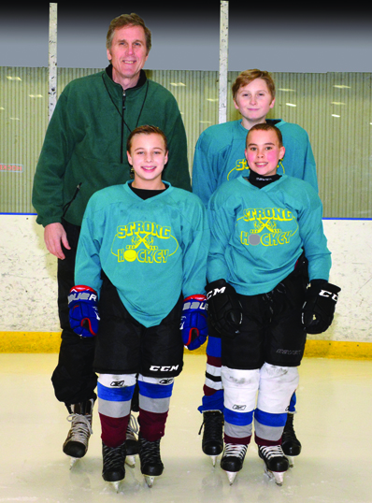

*** Each Age Group Will be Divided Up According to Age and Ability for
Competitive Drills and Scrimmages. 3 Groups total within each age group.
Weekly Agenda
GROUP 1 • AGES 6 - 9
Sunday July 29th Monday – Friday, July 30st – Aug. 3rd
1:00 - 1:30 p.m. Registration 8:30 - 10:00 a.m. 1st On-Ice Session
1:45 Meeting between Parents + Jim Armstrong 10:10 – 11:10 Sport Court Fun
2:00 – 3:00 1st On-Ice Session 11:10 – 12:10 Lunch, fun video
12:30 - 2:00 p.m. 2nd On-Ice Session
Group 2 • AGES 10 - 13
Sunday July 29th Monday – Friday, July 30th – Aug. 3rd
2:00 - 2:30 p.m. Registration 10:00 - 11:30 1st On-Ice Session
2:45 Meeting between Parents + Jim Armstrong 11:40 - 12:40 Sport Court Fun
3:00 – 4:00 1st On-Ice Session 12:40 - 1:40 Lunch, fun video
2:00 - 3:30 p.m. 2nd On-Ice Session
TO REGISTER

1) Please fill out registration below and return.
2) Enclose a check for $260, payable to Strong Hockey. For 2 from the same family the cost is $480.
Send to: Jim Armstrong, Strong Hockey Camp
1370 New Seabury Lane, Victor, NY 14564
QUESTIONS: e-mail Jim at: JTARM@Frontiernet.net
We suggest that you REGISTER EARLY as each group will have a maximum of 32 skaters and 4 goalies only. As always, we will fill up. First come, first served.
For more info: www.stronghockey.com
Please enroll my skater for The Strong Summer Hockey Camp. Please Check
◻ Group 1, Ages 6-9 ◻ Group 2, Ages 10-13
Name of Skater ____________________________________
Address _________________________________________
________________________________________________ “Thanks for all the Great work that you
DOB_____________________________________________ do at camp. It is obvious at first glance
Parent(s) Name____________________________________ that your staff is well organized and
Goalie: Y N (circle one) hands-ons. The kids are getting great
Phone___________________________________________ instruction and having fun playing!”
E-mail ___________________________________________ hockey!”
Person to contact during camp days in case of emergency. Jacques
(Include telephone number.)__________________________
________________________________________________

www.stronghockey.com

